|  |
| --- |
| Indigo |
| Undisclosed Instant Card Checkout Procedure |
| 0.1 DRAFT |

**Confidentiality**

This document is the confidential property of Veneka (pty) ltd, and is supplied under the terms of an agreement with Veneka. It may not be disclosed or used except as is permitted by the agreement or as may be expressly permitted by Veneka (pty) ltd.

All registered or unregistered trademarks and service marks are properties of their respective companies and should be treated as such.

|  |  |  |  |
| --- | --- | --- | --- |
| Version. | Author | Changes | Release Date |
| 0.1 DRAFT | Richard Brenchley | Initial Document | 3 September 2014 |
|  |  |  |  |
|  |  |  |  |
|  |  |  |  |

Table of Contents

1 Heading 1 5

1.1 Business Rules 5

1.2 Tables 6

1.3 Screens 7

1.3.1 UndisclosedCheckout.aspx 7

1.3.2 UndisclosedCheckIn.aspx 7

1.4 Reports 8

1.4.1 Undisclosed Checked Out Cards Report 8

# Heading 1

The purpose of this document is to outline the procedure for checking out instant cards to an operator where by the card number is not present.

## Business Rules

* Cards will be sent to branches in unmarked envelopes.
* Supervisor checks out specific number of cards per product to an operator, the number of cards must be less than or equal to the number of cards at the branch that are in a “CHECKED_IN” status.
* Supervisor does not select cards for checkout but rather enters just the number of cards to checkout to an operator. This number of cards must be the same number as the envelopes given to the operator. During the checkout procedure on Indigo the number of cards entered must be added to any other cards that have been previous checked out the use in the *operator_checkout_cards* table.
* The number of checked out cards can never be less than zero and never more than the total number of cards in “CHECKED_IN” status less the amount of cards already checked out.

MAX = SUM(CHECKED_IN cards) – SUM( checked out cards)

* When Operator issues card to a customer the card envelope will be opened and a card number lookup done in Indigo against *cards* table, if the card is found continue with card capture process. If card is not found ???
* When saving card and account information change card status from “CHECKED_IN” to “ALLOCATED_TO_CUST” status. Decrement the *operator_checkout_cards* table by one.
* If the Maker-Checker process is followed: On reject, *operator_checkout_cards* must be incremented by one and the card previously assigned must be placed back into “CHECKED_IN” status.

## Tables

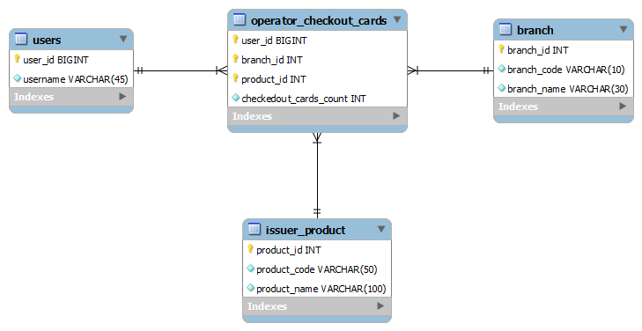

## Screens

A separate vault management screen will be used and the CardCapture screen should handle a card lookup function based on setup of the issuer.

### UndisclosedCheckout.aspx

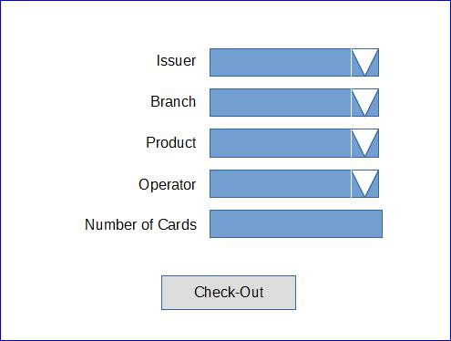

### UndisclosedCheckIn.aspx

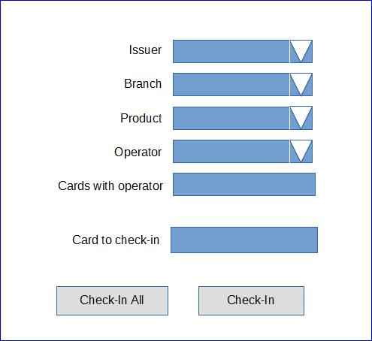

## Reports

### Undisclosed Checked Out Cards Report

